# OUTPUTS:

## Output for the query tell me the time and which day it is:

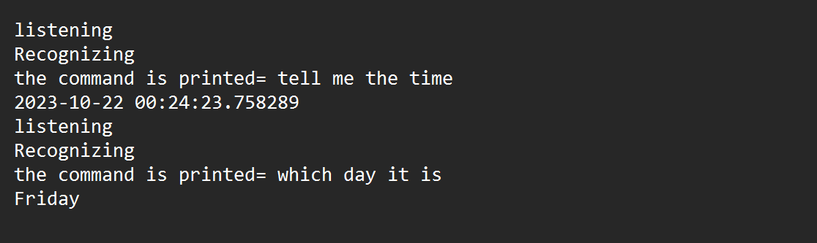

1. Output for the query hello:



## Output for the query bye:



1. Output for the query tell me your name:



## Output for the query from wikipedia:

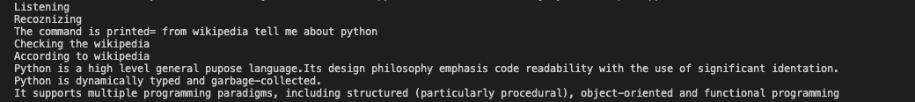

1. Output for the query open Google:

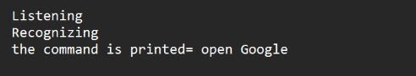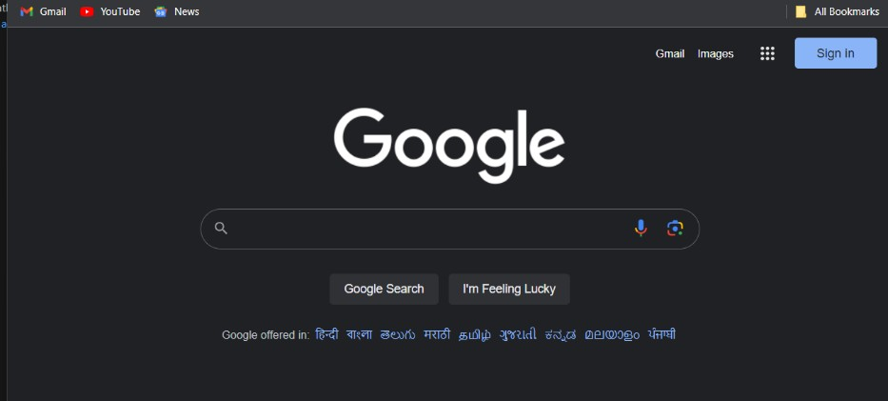

## Output for query open Youtube:

